**Crime Prediction Using Predictive Analytic**

**April Love Naviza**

**Vimitaben Mukeshchanadra Vaidya**

**Wisanu Boonrat**

|  |  |
| --- | --- |
|  | Project Proposal |
|  |  |
|  | Graduate Diploma & Bachelor in Information Technology  4/24/20 |

# Executive Summary

The implementation of predictive policing software that analyses crime data and identifies trends to determine possible crime 'locations' has generated worldwide controversy as their development has progressed. Predictive policing is a part of Predictive analytics which enables Artificial Intelligence and Machine Learning option to find criminal activities based on historical data.

This proposal discusses how the traditional position of the police is changing with the development of modern and readily accessible technology, with focus on predictive police technology, and how the law can encourage this change in role. The project follows agile methodologies with feedback loops where we review and re-evaluate the outcome of each phase by using Jira project management tool and Bitbucket. We also used Microsoft Team to manage and acknowledge with our project group. By use of an agile approach, allows for prioritising and constructing roadmaps based on criteria and objectives. It also helps project teams to provide an analysis and explanation to stakeholders of the overall costs associated with each main target. Timeline to develop this project in 18 weeks which include two blocks. For the first block, the outcome will be descriptive analysis, explore different datasets, and research and apply to model. Implementation and Testing phase will remain for the next block.

At the end of the plan, it is mapped how New Zealand will implement predictive policing technology safely and efficiently, with a focus on transparency and legislation around their use. For the next step, further work will implement a model and as a result, have the highest accuracy outcome-based algorithm and introduce a predictive policing AI-based tool based on the user-defined search.

# Table of Contents

Executive Summary 2

Table of Contents 3

1 Introduction 5

2 Background 5

3 Literature Review 6

4 Proposed Solution 7

4.1 Data Acquisition 8

4.2 Descriptive Analysis 9

4.3 Data Treatment 12

4.4 Predictive Modelling 12

4.5 Performance Evaluation 12

4.6 Model Improvement 12

4.7 Application UI 12

5 Resources 13

6 Budget 13

7 Evaluation 14

7.1 Process Evaluation 14

7.2 Impact Evaluation 14

7.3 Outcome Evaluation 14

7.4 Process Evaluation 14

7.5 Impact Evaluation 14

7.6 Outcome Evaluation 15

8 Initial Plan 15

8.1 Gantt Chart 15

8.2 Milestones 16

9 Challenge 16

10 Reference List 17

11 Appendices 18

11.1 Appendix A 18

11.1.1 Team Agreement 18

11.1.2 Tools 18

11.1.3 Jira 18

11.1.4 Gantt Chart 18

11.1.5 Milestones 18

11.1.6 BitBucket 18

11.2 Appendix B 18

11.2.1 Web Resources 18

**List of Tables**

Table 1 different city dataset with their number features variable, records, and year 8

Table 2 Scrum team & responsibility 13

Table 3 Project budget detail and timeline 14

**List of Figures**

Figure 1. Predictive modelling process. 8

Figure 2 Predictive policing modelling process 8

Figure 3 Variable identification 9

Figure 4 sample: Dataset - a crime in Denver. 10

Figure 5 Understand the criteria of the variables 10

Figure 6 identifies the top 10 crime offences in the country 11

Figure 7 Compare the crime trend in each country by month and year. 11

Figure 8 Evaluate the crime occurrence in each country by the year 11

Figure 9 How to train the model. Retrieved from https://www.youtube.com/watch?v=HcqpanDadyQ 12

Figure 10 predictive policing user interface 13

Figure 11 WBS (Work break-down structure) of project 15

Figure 12 Gantt – Chart 16

Figure 13 Project's milestones from 07/04/2020 - 24/07/2020 16

# Introduction

The most important data analysis techniques and predictive learning techniques are Artificial Intelligence (AI), Machine Learning (ML). The future of crime-solving and prevention is documented widely on predictive policing approaches and artificial intelligence technologies (n.d). Technological advancement includes the implementation of technology that can allow a police force to predict where and when a crime will occur by analysing data and trends (Koops, 2009). The most serious crimes recorded in New Zealand were theft, assault and fraud. At the same time, the Māori population was more likely to be victims of crime, with 37 per cent of native people reporting a criminal incident in the last year (Roy,2018). Depending on the figures on New Zealand's police crime in February 2020, robbery victims increased 11.7%, Burglary growing 7.2% more and Assault increased by 10.7% from the previous year[1]. This research aims to build an overview of existing crime data and related data from different fields, including geographic patterns, population, education, housing, economy, and environment, to detect future criminal activities. The purpose of these studies is to build a Predictive Policy Prototype.

This approach will help a department for crime forecasting in a specific field, resource management development and crime reduction. Proof of concept and the outcome of this project can be distributed for future work opportunities, business strategies, financing, and business products to the community and domain experts.

We decided to develop a prototype framework that analyses the crime data collected from [Crime Statistics Publication](https://www.police.govt.nz/about-us/publications-statistics/data-and-statistics/crime-statistics-publications). Data scanning, cleaning and transformation is important to generate quality inputs for prediction models.When using predictive algorithms in machine learning, historical criminal data can be separated into test and trial data. We will then train different models with the test component and check the test components. The models are then tested against evaluation metrics. An agile approach was selected to handle this project so that feedback can be timely checked and collected from the results. This method will be iterated to achieve reasonable crime prediction accuracy.

# Background

Predictive policing is trying to utilise information resources, data analysis technology and evidence-based models to minimise crime and improve public safety. According to the National Institute of Justice, the predictive policing strategy is no replacement for conventional policing strategies. Rather it builds on current approaches such as problem-oriented policing, neighbourhood policing, intelligence-led police and hot spot policing (n.d).The use of modern technology by police departments is also important, as criminals are also capable of accessing new technologies and using them to the advantage of committing crimes. In general, technology may be used for the work of the police or for carrying out a police operation, for example, in the distribution of resources.

Predictive policing technology has had significant success in minimising and stopping crime. In the United States of America, where these techniques were introduced and used in various jurisdictions, the Los Angeles Police Department (LAPD) observed a 30 per cent decrease in crime and a 55% decline in the first two months of 2014 when predictive policing techniques were used (BBC News, 2004). Police in the San Fernando Valley Foothill Area, while using PredPol for four months, reported property crime declined by 13 per cent, while it increased by 0.4 per cent in the rest of the city (Chammah,2016).

New Zealand (NZ) has not introduced advanced policing technology or only investigated it. The New Zealand Police currently use different tools to promote their duties as police officers. These technologies are devices driven by experience, rather than predictive. The 'Auror' software is the closest application to the police predictive application[2]. While it does not function as a predictive police device, it can be used in this way. This software allows access to Retails to upload CCTV images of criminals and their age, sex, ethnicity, height and vehicle information which are then forwarded to police to gather real-time information and alert communities to criminals in the region by use of the mobile devices (Dickinson, 2017).

The most common crimes in New Zealand are burglary, assault and theft and victimisation. However, it is noticeable that burglaries are the highest crime category that happened most frequent in south Auckland. According to estimates, of the more than 17100 registered city-wide burglaries more than 6700-39%-were registered in South Auckland. 29% or all the burglaries were recorded in central Auckland police stations – just over 4900. West Auckland had just over 20 per cent, or 3400, burglaries this year in some high-profile violent crimes. The patterns of crimes in New Zealand are primarily evolving year by year and month after viewing and evaluating the criminal dataset from Stats NZ. In 2015 and 2016, the crime rate was higher than this year. Nevertheless, much of the crime occurred from March to June, based on the Statistics NZ dataset. Therefore, implementing a predictive analysis to predict and minimise crimes using advanced AI (Artificial Intelligence) and Machine Learning techniques will be one of the best alternatives for the New Zealand police force.

# Literature Review

Current literature on predictive police and descriptive analysis was analysed to carry out the study for this proposal. Such research materials consist of books, magazines, journals and multiple governments, news, and academic websites.

Based on the literature, it is evident that predictive analysis is a predictive policing component which applies data to mathematical algorithms to forecast future trends. They are closely linked to the words "data mining" and "predictive analysis." Merriam-Webster's describes data mining as "the process of looking for useful patterns and trends using large volumes of computerised data”. McCue makes it different between two types of quantitative and descriptive data mining; these are both methods of predictive analysis.

On the second research paper, according to Breen and Jamie explores how the traditional position of the police is evolving by adopting modern and readily available technology, with particular emphasis on predictive police technologies, and how the law can encourage this change in the role of police (Breen & Jamie, 2017). The paper then analyses both the potential of the new technology to be used as well as its existing application and the negative issues that it could create. A link between public safety and the protection of persons against racism with the most economical and realistic vision is important to promote the use of predictive policing technology.

Moreover, the third part of the literature describes the various historical data on crime prediction activities. It forecasts the future crime, according to place, date, day, season and year, after analysing the data. Almaw & Kadam (2018) published the "Survey Paper on Crime Prediction using Ensemble Approach," a publication to determine the correct predictive modelling technique, which found that several researchers compared the performance of ML technology. The journal's comparison table includes algorithms in many datasets. Some algorithms like Naïve Bayes, Random Forest, and Decision Tree, KNN are common for predictive modelling researchers. A survey is carried out to enhance crime prediction by effective data collection and data mining techniques. Additionally, providing this kind of information will help to improve people's decisions for their living and travel.

These findings have many effects on machine-learning predictive police research in New Zealand, particularly in South Auckland. Historical crime data can be a major data collection. Other data sets to improve the performance of the forecast may include regional characteristics, population, housing, education, economics, and environment. Dynamic features can be different, based on the dataset. As per research on Table -1 city, dataset defines dynamic features could be Assault, Drug, Burglary and Theft. When the predictive models are developed, the efficiency of datasets is evaluated. Naïve Bayes, Random Forest and Decision Tree are top priority algorithms of our research prototype. The group of methods like boosting, bagging, and stacking are used to generate better forecasts.

Predictive police have been investigated in New Zealand to the best of our understanding, but there is still no technology that forecasts the crimes using this concept. We expect our research and development of prototypes are useful for commercial product implementation. Predictive police are not difficult in finding crime scenes and suspects. However, it is about plans for immediate, near and remote responses to crimes.

# Proposed Solution

To identify the potentially criminal activities based on historical data, we proposed an AI-based predictive policing tool, which makes use of New Zealand’s crime data and predictive analytics models for the crime prediction. The figure below shows how the prototype will be be developed, which consists of 6 stages from data acquisition to model improvement.

Figure 1. Predictive modelling process.

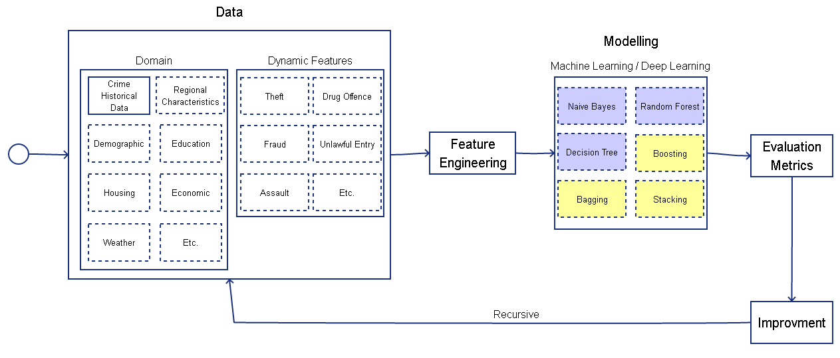

Figure 2 Predictive policing modelling process

## Data Acquisition

In Machine Learning, it is essential to have multiple datasets that have enough features or variables to precisely train the learning model. In this stage, we have considered the crime dataset in Boston, Denver, London, San Francisco, and New Zealand.

Table 1 different city dataset with their number features variable, records, and year

|  |  |  |  |
| --- | --- | --- | --- |
| **Dataset** | **Variables** | **Entries** | **Year Range** |
| LONDON | 7 | 1048575 | 2008-2016 |
| SAN FRANCISCO | 13 | 150501 | 2016 |
| DENVER | 16 | 466840 | 2015-2020 |
| BOSTON | 17 | 319073 | 2015-2018 |
| NEW ZEALAND | 23 | 632656 | 2014-2019 |

## Descriptive Analysis

Once the data have been classified, a thorough assessment and analysis will be performed in the dataset. The intention in this process is to understand the different features, identify the association between multiple data and detect errors or missing values. These include numerical and graphical representation which summarizes the records and extract relevant information.

1. Variable Identification

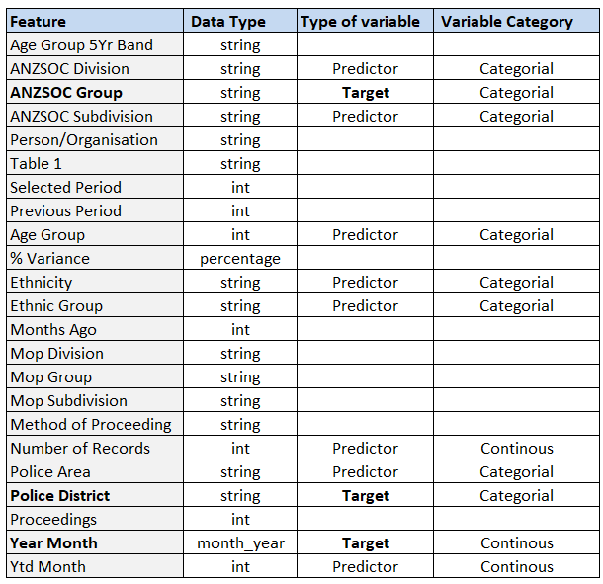

Figure 3 Variable identification

1. Identified the missing values using python.

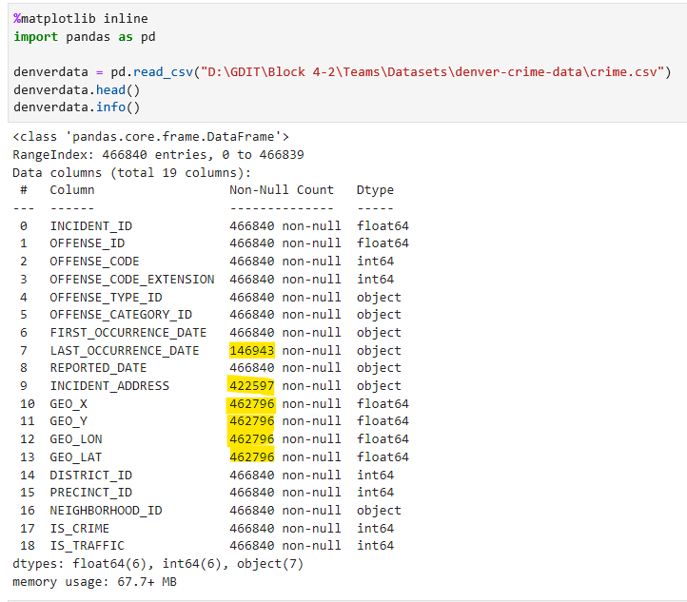

Figure 4 sample: Dataset - a crime in Denver.

1. 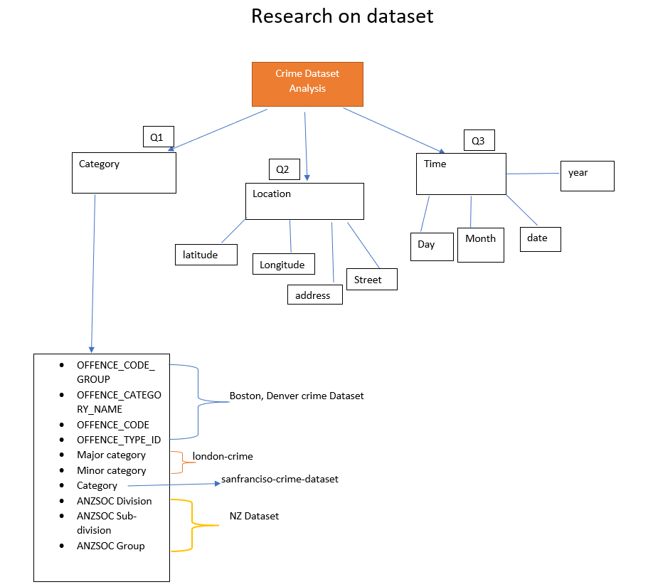Analyse the relationship of the data:

Figure 5 Understand the criteria of the variables

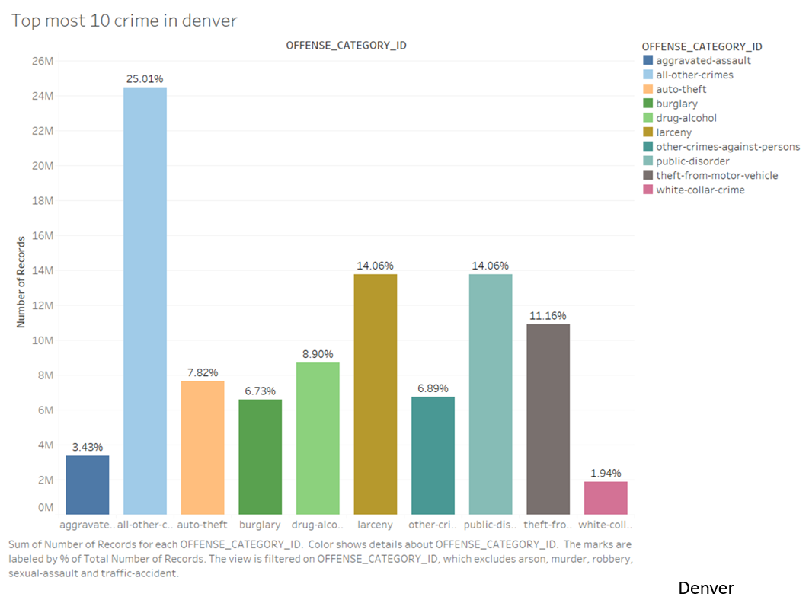

Figure 6 identifies the top 10 crime offences in the country

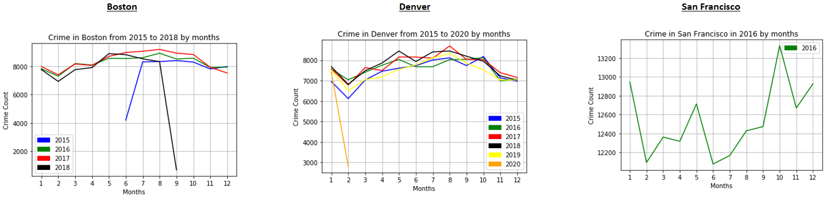

Figure 7 Compare the crime trend in each country by month and year.

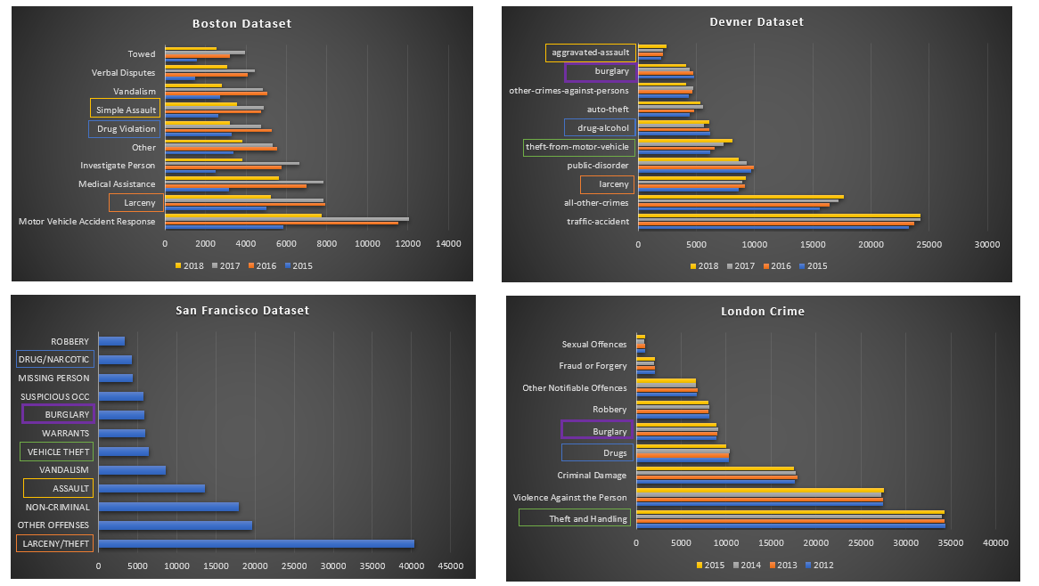

Figure 8 Evaluate the crime occurrence in each country by the year

The top 10 crimes in Denver City are listed above Figure 6. The analysis of three different countries' crime rates based on the month and the year indicated in figure 7. However, Figure 8 demonstrates that patterns were identical year after year for different crime categories and defines the popular group of crime from the city of Boston, Denver, London and San Francisco.

## Data Treatment

In this stage, the data will go through various data transformations such as scrubbing the missing values, filtering, manipulation, and feature engineering as the accuracy of the model prediction depends on the quality of the data.

The following process enables to prepare data for building the predictive model:

* Missing values treatment
* Outlier treatment
* Variable transformation
* Variable creation

## Predictive Modelling

When the dataset has been completely formulated, it will be divided into two-part, trial and validate (70:30). It is expected to gather many results by using related predictive algorithms. The 30% will be used as a model, to predict the possible event.

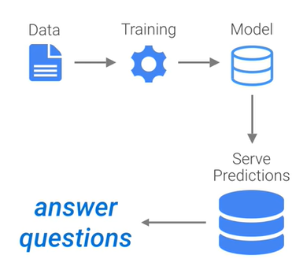

Figure 9 How to train the model. Retrieved from https://www.youtube.com/watch?v=HcqpanDadyQ

## Performance Evaluation

In this phase, the team considered the different metrics to evaluate the predictive model performance. Initially, it will establish a benchmark wherein the performance will be compared to other parameters. Each will give a contribution in making a decision and support the accuracy of the predictive model.

## Model Improvement

Different technics combine or control some models to produce an optimal predictive model. In this phase, we will further explore Algorithm Tuning and Ensemble Methods.

It is essential to recognise the issues and explore various viewpoints before moving deep into improving the model. It helps to decide which processes we need to conduct and concentrate on, such as data normalisation, treat missing or outlier values, data flexibility and selection. And to achieve the best possible outcome, it is expected for the predictive modelling to undergo numerous iterations and may acquire additional dataset size or new features.

## Application UI

Part of this study is to develop a prototype of a Predictive Policing tool. It will give an option to filter and select the following criteria: Crime Type, Location, Date and Time to display the forecast crime offence that may occur in that specific area.

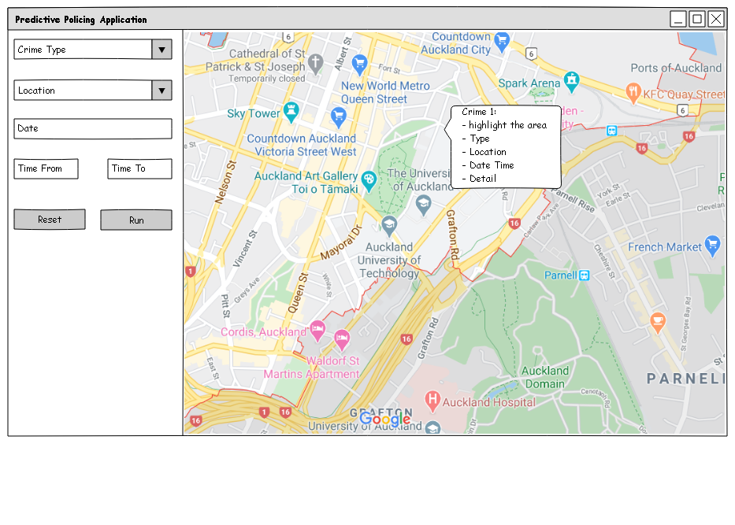

Figure 10 predictive policing user interface

# Resources

Despite the use of an Agile method to develop the project, the Project Manager and Scrum Master roles will be rotated in each sprint. All team members are expected to be the full stack developer.

Table 2 Scrum team & responsibility

|  |  |  |
| --- | --- | --- |
| **Roles** | **Names** | **Responsibilities** |
| Product owner | Dr. Farhad Mehdipour | * Declare the goal and objective. * Guide the project in the correct direction. * Review and feedback on a weekly basis or as the team requested. * Make decisions. |
| Project manager, scrum master, developer and tester | April Love Naviza | * Rotate the project manager and scrum master * Manage product backlog and Jira tickets. * Be responsible for the assigned Jira tickets. * Research and develop the prototype and final product in both data modelling and UI. * Be responsible for the documentation tasks. |
| Vimitaben Mukeshchanadra Vaidya |

# Budget

This section shows the total working days and the cost of this project. The project has four sprints starting from 07/04/2020 – 24/07/2020. There are 75 working days, 30 weekend days, and five public holidays. The average time spent on a working day is 6 hours. The cost estimation for this project is 27,000 NZD.

Table 3 Project budget detail and timeline

|  |  |  |  |  |  |  |  |
| --- | --- | --- | --- | --- | --- | --- | --- |
| **Sprints** | **Phases** | **Durations**  **(dd/MM/2020)** | **Working Days** | **# of Developers** | **Working days**  **(Hours)** | **Hourly Rate** | **Cost (NZD)** |
| 1 | Proposal | 07/04 – 24/04 | 12 | 3 | 6 | 20 | 4,320 |
| 2 | Planning | 27/04 – 22/05 | 19 | 3 | 6 | 20 | 6,840 |
| 3 | Prototyping | 25/05 – 19/06 | 19 | 3 | 6 | 20 | 6,840 |
| 4 | Deployment | 22/06 – 24/07 | 25 | 3 | 6 | 20 | 9,000 |
|  |  |  | 75 |  |  |  | 27,000 |

# Evaluation

The project evaluation will be used to measure the activities of development processes and quality of the prototype and final product. The evaluation criteria will be aligned with the goal and objective of the project. Thus, the proposed evaluations are divided into three parts.

## Process Evaluation

All inputs, activities, and outputs of each development stage will be measured that they are implemented as intended. The development team has defined the Team Agreement and tools for this project to ensure that all activities of the software development process can be tracked and reviewed by the authorised stakeholders. Please see Appendix A for more information.

## Impact Evaluation

This evaluation aims to answer the question of how the outcome would have changed if the intervention had not been undertaken based on the cause-and-effect analysis. The Fishbone diagram will be presented in the Planning document.

## Outcome Evaluation

The results of the application will be determined how well the application achieves its objectives. Both qualitative and quantitative methods will be used in the observations.

* Qualitative method will verify that the application has a good design and user-friendly.
* The quantitative method will verify that the results of crime prediction will have acceptable accuracy and precision in every execution.

## Process Evaluation

All inputs, activities, and outputs of each development stage will be measured that they are implemented as intended.

## Impact Evaluation

This evaluation aims to answer the question of how the outcome would have changed if the intervention had not been undertaken based on the cause-and-effect analysis. The Fishbone diagram will be presented in the Planning document.

## Outcome Evaluation

The results of the application will be determined how well the application achieves its objectives. Both qualitative and quantitative methods will be used in the observations.

* Qualitative method will verify that the application has a good design and user-friendly.
* The quantitative method will verify that the results of crime prediction will have acceptable accuracy and precision in every execution.

# Initial Plan

The project will be developed under the Agile method by aiming to update the project’s status, refine the requirements, and get feedback from the Product Owner every week. There will be four sprints along with the project’s phases, Proposal, Planning, Prototyping, and Product Implementation.

## Gantt Chart

In this project, we will use the WBS Gantt-Chart in Jira to visualize the full suite of our project schedule, stories, and resource allocation. WBS Gantt-Chart is an add-on that needs to be installed in Jira. It transforms the Jira project into Gantt chart and displays a work breakdown structure (WBS) of all the issues and timeline overview. As it is sync in the Jira project, it automatically updates the list of tasks, status, priority, and assignee.

* **Identify Essential Tasks and Relationship**

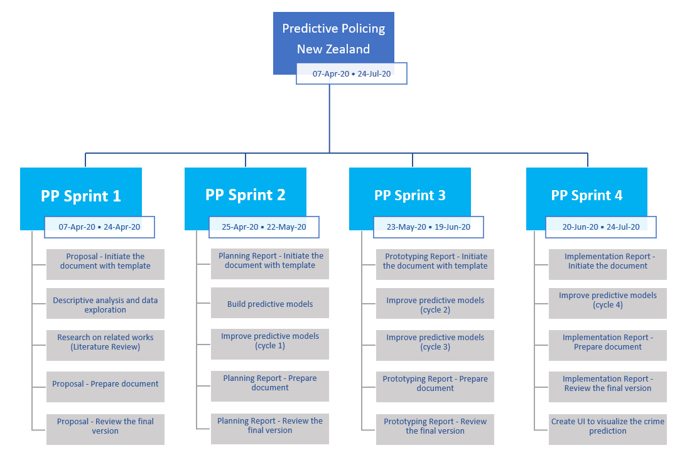This is the breakdown of the tasks and the estimated duration on each sprint. The chart does not represent the relationship between the tasks in the project. Most of the activities are parallel tasks.

Figure 11 WBS (Work break-down structure) of project

* **Gantt Chart**

Please see Appendix A to open the Gantt chart in Excel file.

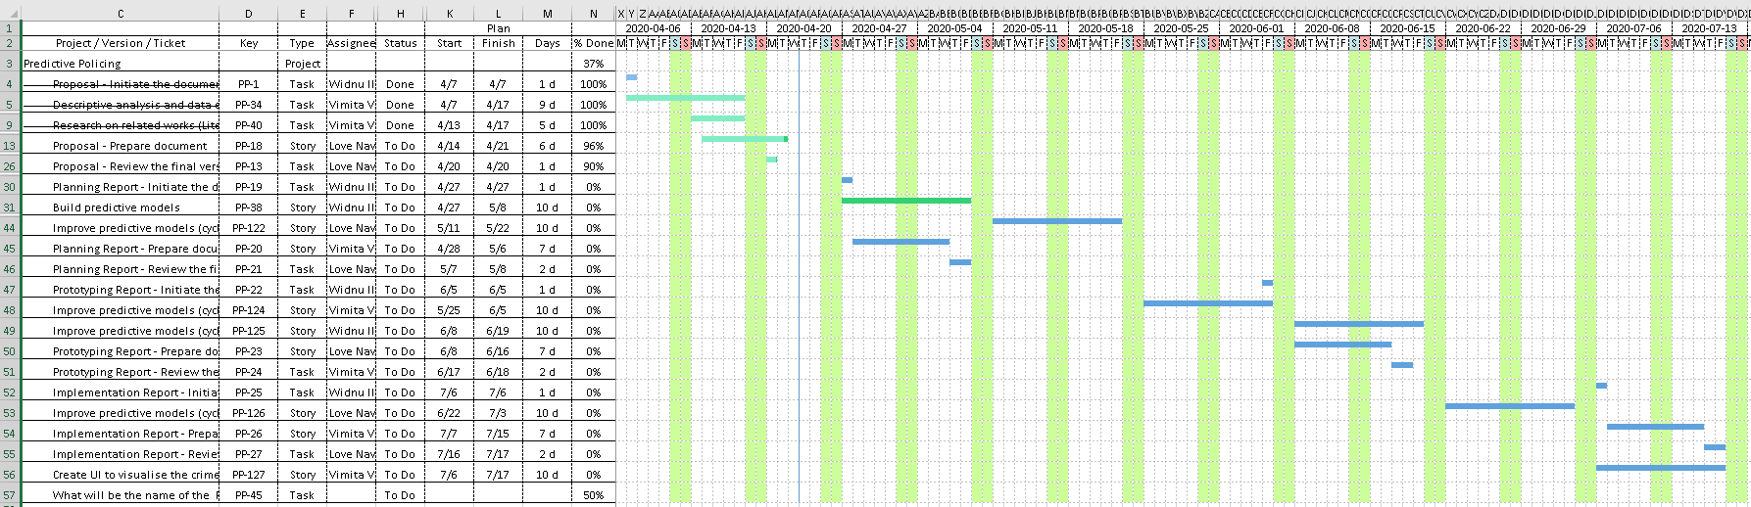

Figure 12 Gantt – Chart

## Milestones

In each sprint, there are 3 main milestones as follows:

1. Start development: The team will start the coding tasks.
2. Freeze code: The team will save a code snapshot for backup.
3. Finalise report: The report will be reviewed. No major changes.

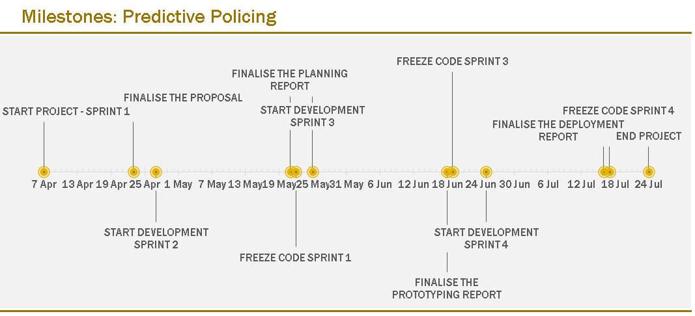

Figure 13 Project's milestones from 07/04/2020 - 24/07/2020

# Challenge

Data Analytics process faces several challenges. The key challenges during data analysis, cleaning, visualizing data, modelling data are followed,

1. Expertise is a challenge as predictive analytical approaches are typically designed for data scientists with an in-depth understanding of statistics, R and Python.
2. Wide range of the dataset

* There are many available datasets provided by the New Zealand Government, which critical decision for a data analyst to decide which one is effective for better predictive policing.
* Dynamic features are different depending on data set; therefore, common features for all dataset are difficult to predict.

1. Visual representation of data

* You need to display the data in a simple and readable format for the public. It may be a challenging job to process unstructured data and then visually attractive.

1. Difficult to decide which algorithm should give higher accuracy during modelling data.

# Reference List

Almaw, A., & Kadam, K. (2018). Crime Data Analysis and Prediction Using Ensemble Learning. *2018 Second International Conference on Intelligent Computing and Control Systems (ICICCS)*. doi: 10.1109/iccons.2018.8663186

Breen, & Jamie.(2017). The Changing Role of New Zealand Police with The Introduction of New Technologies: How Far Should 3 The Law Respond? Retrieved from <http://researcharchive.vuw.ac.nz/handle/10063/7954>

Can artificial intelligence and predictive policing make us safer? (n.d.). Retrieved from <http://defsecmedia.co.nz/homeland-security/summer-2017-predictive-policing/>

Chammah, M. (2016, February 3). In the aftermath of Michael Brown's death, St. Louis cops embrace crime-predicting software. Retrieved from <https://www.theverge.com/2016/2/3/10895804/st-louis-police-hunchlab-predictive-policing-marshall-project>

Dickinson, M. (2017, August 29). Science & Tech: Big data on crime. Retrieved from <https://www.nzherald.co.nz/technology/news/article.cfm?c_id=5&objectid=11581851>

How predictive policing works in the US. (2014, April 1). Retrieved from <https://www.bbc.com/news/av/uk-england-london-26837251/how-predictive-policing-works-in-the-us>

Overview of Predictive Policing. (n.d.). Retrieved from <https://nij.ojp.gov/topics/articles/overview-predictive-policing>

policedata.nz. (n.d.). Retrieved from <https://www.police.govt.nz/about-us/publications-statistics/data-and-statistics/policedatanz>

Roy, E. A. (2018, December 20). New Zealand survey suggests real crime figures could be seven times official tally. Retrieved from <https://www.theguardian.com/world/2018/dec/20/new-zealand-survey-suggests-real-figures-could-be-seven-times-official-tally>

# Appendices

## Appendix A

### Team Agreement

[https://otagopoly.sharepoint.com/sites/PredictivePolicing/_layouts/15/Doc.aspx?OR=teams&action=edit&sourcedoc={73DE4091-CCBD-460A-8206-E1669EA4845F}](https://otagopoly.sharepoint.com/sites/PredictivePolicing/_layouts/15/Doc.aspx?OR=teams&action=edit&sourcedoc=%7b73DE4091-CCBD-460A-8206-E1669EA4845F%7d)

### Tools

[https://otagopoly.sharepoint.com/sites/PredictivePolicing/_layouts/15/Doc.aspx?OR=teams&action=edit&sourcedoc={FC28C08D-ADA4-420A-8B56-B19371A584EF}](https://otagopoly.sharepoint.com/sites/PredictivePolicing/_layouts/15/Doc.aspx?OR=teams&action=edit&sourcedoc=%7bFC28C08D-ADA4-420A-8B56-B19371A584EF%7d)

### Jira

<https://opaiccrimeprediction.atlassian.net/secure/RapidBoard.jspa?rapidView=1&projectKey=PP&view=planning.nodetail&issueLimit=100>

### Gantt Chart

[https://otagopoly.sharepoint.com/sites/PredictivePolicing/_layouts/15/Doc.aspx?OR=teams&action=edit&sourcedoc={59BAD8FB-5C1D-4D90-8424-7F21671A0143}](https://otagopoly.sharepoint.com/sites/PredictivePolicing/_layouts/15/Doc.aspx?OR=teams&action=edit&sourcedoc=%7b59BAD8FB-5C1D-4D90-8424-7F21671A0143%7d)

### Milestones

[https://otagopoly.sharepoint.com/sites/PredictivePolicing/_layouts/15/Doc.aspx?OR=teams&action=edit&sourcedoc={17032E2E-C7E3-430B-91D8-7453AD4B6A2B}](https://otagopoly.sharepoint.com/sites/PredictivePolicing/_layouts/15/Doc.aspx?OR=teams&action=edit&sourcedoc=%7b17032E2E-C7E3-430B-91D8-7453AD4B6A2B%7d)

### BitBucket

<https://bitbucket.org/wisanuboonrat/predictive_policing/src/master/>

## Appendix B

### Web Resources

<https://www.theclassroom.com/difference-between-qualitative-quantitative-evaluation-8281411.html>

<https://study.com/academy/lesson/outcome-evaluation-definition-program-effectiveness.html>

<https://programs.online.american.edu/online-graduate-certificates/project-monitoring/resources/what-is-impact-evaluation>

<http://mypeer.org.au/monitoring-evaluation/types-of-evaluation/>

<https://analyticsindiamag.com/what-is-predictive-model-performance-evaluation-and-why-is-it-important/>

<http://www.stuff.co.nz/national/10291306/South-Auckland-hit-by-most-burglaries>

<http://nzdotstat.stats.govt.nz/wbos/Index.aspx?DataSetCode=TABLECODE7405&_ga=2.31081594.418180889.1567998114-1108144724.1566977284>

<https://www.merriam-webster.com/dictionary/data%20mining>

1. <https://www.police.govt.nz/about-us/publications-statistics/data-and-statistics/crime-statistics-publications>
2. <https://www.auror.co/>